**DAILY ONLINE ACTIVITIES SUMMARY**

|  |  |  |  |  |  |  |  |
| --- | --- | --- | --- | --- | --- | --- | --- |
| **Date:** | **19/06/2020** | | | | **Name:** | **Churashma** | |
| **Sem & Sec** | **4th SEM 'A' Section** | | | | **USN:** | **4AL18CS019** | |
| **Online Test Summary** | | | | | | | |
| **Subject** | | **Micro controller and embedded system** | | | | | |
| **Max. Marks** | | **20** | | **Score** | | **20** | |
| **Certification Course Summary** | | | | | | | |
| **Course** | **Introduction to R** | | | | | | |
| **Certificate Provider** | | | **greatlearning academy** | **Duration** | | | **3.0 hours** |
| **Coding Challenges** | | | | | | | |
| **Problem statement 1: Write a C Program to Count total set bits in all numbers from 1 to n.** | | | | | | | |
| **Status: completed** | | | | | | | |
| **Uploaded the report in Github** | | | | **yes** | | | |
| **If yes Repository name** | | | | **https://github.com/Churashma/Lockdown-coding** | | | |
| **Uploaded the report in slack** | | | | **yes** | | | |

ONLINE TEST DETAILS: MES test was scheduled from 03:00 pm to 03:30 pm .The portion for the IA was module 4 there were 20 questions and the time assigned was 30 minutes the questions were mcq type.

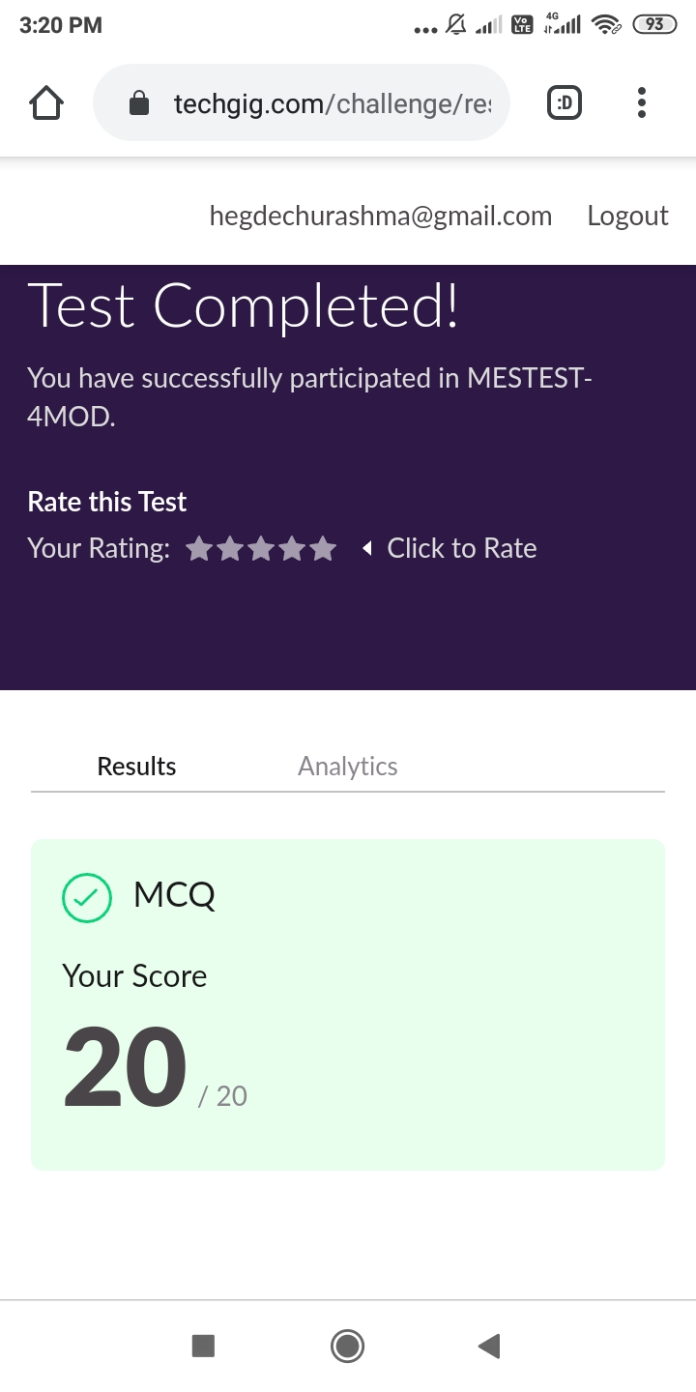

CERTIFICATION COURSE DETAILS: I started with the next certification course that is Introduction to R. In that I studied about Introduction to R for analytics outline and also I studied about R_Overview and preliminary steps . R supports two-dimensional objects also. There are examples of the two most popular data structures used in R: the matrix and data.frame. R is a programming language and software environment for statistical analysis, graphics representation and reporting. R was created by Ross Ihaka and Robert Gentleman at the University of Auckland, New Zealand, and is currently developed by the R Development Core Team.

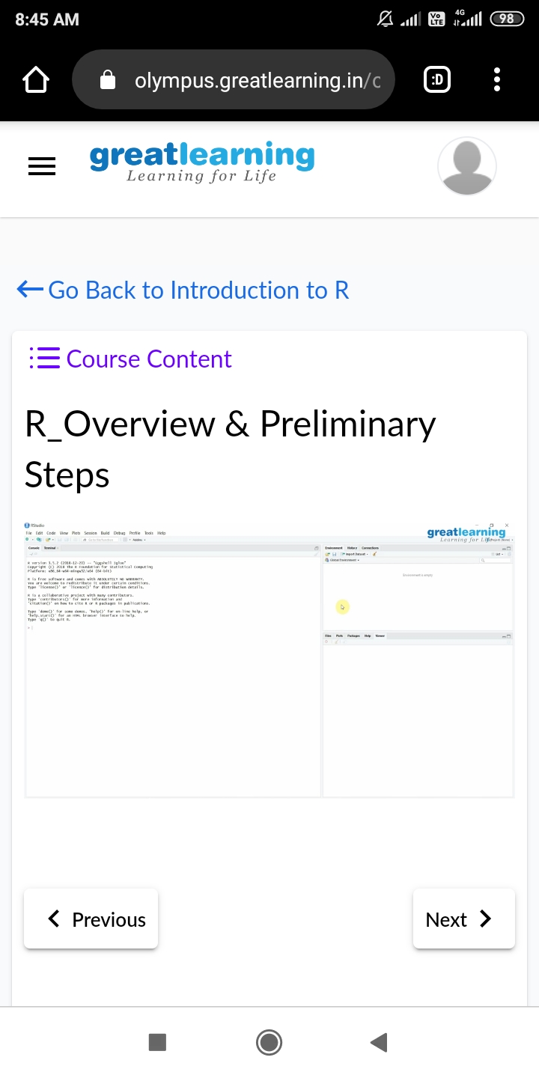

**CODING CHALLENGES DETAILS**:

Problem statement 1: Write a C Program to Count total set bits in all numbers from 1 to n.

